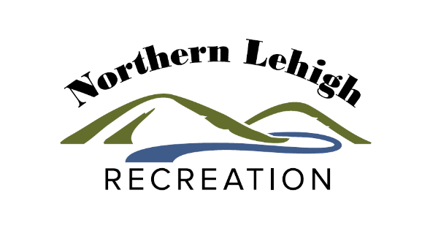
Tennis for
Beginners

Fall Session 2020
Eagles Nest Park
September 3rd to October 9th
Every Thursday
5:00 pm: 4th – 6th Graders
6:00 pm: Adults

Class Fee:
$30.00 / 6 week session- $25 for 2nd Family member

Participant Name________________________________________________________________________
Home Phone_________________________________ Cell Phone_________________________________
Email: _________________________________________________________________________________
Address________________________________________________________________________________
City____________________________________________ State_______________ Zip_________________

PLEASE LIST ANY MEDICAL CONDITIONS AND/OR ALLERGIES THAT WE SHOULD KNOW ABOUT:
______________________________________________________________________________________________
______________________________________________________________________________________________
______________________________________________________________________________________________

EMERGENCY CONTACT INFORMATION:

Name__________________________________________________________________________________
Home Phone: ______________________ Work: ______________________ Cell: _____________________

Northern Lehigh Recreation Authority
POLICIES, WAIVER AND ASSUMPTION OF RISK

Program policies:
- There are no scheduled classes during holidays or school closings.
- It is suggested that participants bring water with them to ALL classes.
- Northern Lehigh Recreation is not responsible for lost or stolen items.
- All participants under the age of 18 must have a parent or guardian complete a program registration form prior to participating.
- All classes are subject to cancellation and/or change based on the availability of qualified instructors, facilities, and participation.
- A medical examination is not required for participation. However, if you know that you have a medical/health condition and you will be starting a new exercise program and/or will be significantly increasing your current activity level, it is necessary that you talk with your doctor before participating.
- NLRA staff may occasionally take photos and/or video of participants enrolled in the Programs, classes and special events. These photos and video clips may be used in the newsletters, websites and/or future print and video productions. If you do not wish to have your photo taken, please tell our photographers.

Waiver:
In consideration of the Participant’s involvement and participation in Northern Lehigh Recreation Authority (“NLRA”) programs, activities, and/or events, (collectively “Program(s)”), and/or the use of Program Facilities, and intending to be legally bound, the undersigned (or Parent or Guardian of the Participant if Participant is a minor):

Acknowledge, fully understand, and assume all the forgoing risks with participation in NLRA Programs, all of which involve risk of serious personal injury, injury to personal property, including permanent disability and death, and severe social and economic losses which might result not only from their own actions, but inactions or negligence of others, the rules of play, the nature of the Programs, or the condition of the Facilities, premises or of any equipment used. Further, that there may be other risks not known to us or not reasonably foreseeable at this time. In consideration of my participation in the Programs and use of the Facilities, I agree on behalf of myself and my heirs, executors, personal representatives and anyone else acting on my behalf to Voluntarily remise, release, indemnify, covenant not to sue, and forever discharge the Northern Lehigh Recreation Authority, and its Board of Directors, officers, employees, contractors, and/or volunteers from any and all injuries, losses or damages of any kind whatsoever suffered by me as a result of my voluntary use of the facilities and participation in the Programs, whether supervised or on my own, and whether attributable to negligence, gross negligence, or recklessness on the part of such persons or entities.

Authorization for Medical Treatment/Indemnification
I hereby authorize and give my consent to the NLRA and its officers, employees, contractors, and/or volunteers, and any licensed physician to perform upon or administer to myself/ my child (the participant), as identified on this registration form, any reasonable and necessary medical, surgical or emergency treatment as necessary in their best judgment to stabilize his/her condition or to preserve life or limb. I further agree to pay for all necessary medical treatment as so authorized and to hold harmless and release the NLRA and its’ officers, employees, contractors, and/or volunteers from any obligation or responsibility with respect thereto. I further represent that myself/my child (the participant) has no condition, illness, disease, disability, or other limitation that would pose any potential risk of bodily harm or injury, except as disclosed on this registration form. I further represent that myself/my child (the participant) has no allergy to any medication or other condition limiting the administration of drugs or medication, except as otherwise disclosed on this registration form. I further agree to indemnify and hold harmless any officers, employees, contractors, and/or volunteers of the NLRA from any and all actions, causes of actions, suits, injury claims, or demands asserted by any third party, with respect to any act, omission, wrongful or unlawful conduct during the course of participation in a program/activity. This Agreement shall be binding upon the heirs, personal representatives, successors, and assigns of the undersigned.

THE UNDERSIGNED HAVE READ THE ABOVE WAIVER AND AUTHORIZATION FOR MEDICAL TRAETMENT AND UNDERSTAND THAT THEY HAVE GIVEN UP SUBSTANTIAL RIGHTS BY SIGNING IT, AND SIGN IT VOLUNTARILY.

________________________________________________________ _______________________
(Signature of Participant or Parent/Guardian of Participant) (Date)

________________________________________________________
Name (Please Print)

